SIMATS ENGINEERING

ASSESSMENT TOOL 3

COURSE CODE: CSA14 COURSE NAME: COMPILER DESIGN

COURSE OUTCOME COVERED

CO5: Develop code optimization and Code Generation using DAG representation with data flow analysis to produce optimized target code ( BL3)

Assessment Tool Weightage: 10%

QUESTIONS: 30 Total Marks:60

Annexure A

MOCK INTERVIEW

Code of Conduct:

I (Name / Reg No) certify that this submission is my original work and that I have adhered to the guidelines specified for this assessment.
I understand that any violation of academic integrity rules will result in disciplinary action.

Signature of the student:

Annexure A

MOCK INTERVIEW

QUESTIONS

- What is a compiler?

- What are the different phases of a compiler?

- What is lexical analysis?

- What is the role of a lexical analyzer?

- What is a token? Give an example.

- What is a lexeme?

- What is the difference between token and lexeme?

- What is a pattern in lexical analysis?

- What are keywords and identifiers?

- What are the common errors detected by a lexical analyzer?

- What is syntax analysis?

- What is the role of a parser?

- What is a parse tree?

- What is the difference between parse tree and syntax tree?

- What is ambiguity in grammar?

- What is left recursion?

- Why should left recursion be removed?

- What is left factoring?

- What is predictive parsing?

- What is the dangling else problem?

- What is FIRST set?

- What is FOLLOW set?

- Why are FIRST and FOLLOW sets important?

- What is LL(1) grammar?

- What is an LL(1) parsing table?

- When does a conflict occur in LL(1) parsing?

- Why is ambiguous grammar not suitable for LL(1)?

- How does a predictive parser work?

- What is bottom-up parsing?

- What is shift-reduce parsing?

- What is a handle?

- What is handle pruning?

- What is a shift-reduce conflict?

- What is a reduce-reduce conflict?

- What is operator precedence parsing?

- What is the difference between top-down and bottom-up parsing?

- What is LR parsing?

- What is an augmented grammar?

- What is closure in LR parsing?

- What is GOTO function?

- What is SLR parsing?

- What is the difference between LR(0) and SLR?

- What is semantic analysis?

- What is a symbol table?

- What information is stored in a symbol table?

- What is type checking?

- What is intermediate code generation?

- What is three-address code?

- What is code optimization?

- What is peephole optimization?

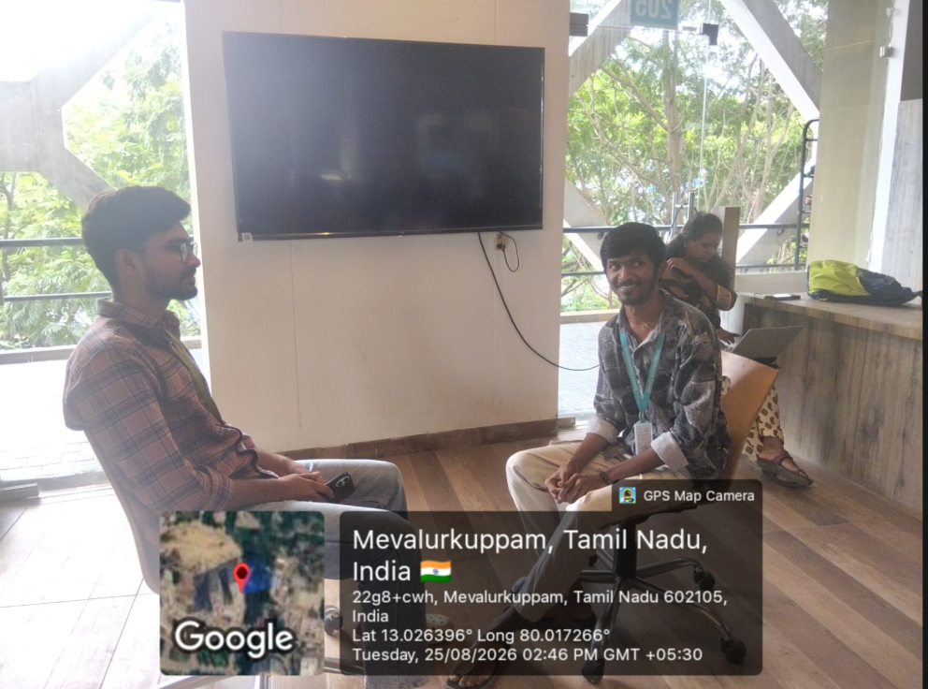

RUBRICS FOR CALCULATION:

Criteria | Weightag e | Level 4 (Exemplary) | Level 3 (Proficient) | Level 2 (Developing) | Level 1 (Beginning)
Technical Knowledge | 25 | Demonstrates strong and accurate subject knowledge with in-depth understanding | Shows good knowledge with minor gaps | Basic knowledge with noticeable errors | Lacks fundamental  technical knowledge
Problem Solving | 25 | Solves problems logically and applies concepts effectively in real scenarios | Applies concepts with moderate accuracy | Limited problem-solving ability; requires guidance | Unable to solve or apply concepts
Analytical Thinking | 15 | Analyzes questions critically and provides well-structured, logical answers | Provides reasonable analysis with some structure | Superficial or partially structured responses | No analytical thinking was demonstrated
Communicatio n | 15 | Communicates clearly, confidently, and professionally with proper terminology | Communicate s well with minor hesitation | Communication lacks clarity or confidence | Unable to communicate effectively
Confidence | 15 | Displays high confidence, positive attitude, and professional behavior throughout | Shows good confidence with minor issues | Low confidence; inconsistent behavior | Lacks confidence and professionalism
Response to Questions | 10 | Responds accurately, promptly, and elaborates with relevant examples | Responds correctly but with limited depth | Partial responses; needs prompting | Unable to respond appropriately

